Advanced Graphics Programming (CUP688)
Tutorial 10b – Environment Reflection

Introduction
A cheap method of creating richer and more realistic looking renderers is to use static environment reflections and environment mapping. This tutorial will show the steps for reflecting the skybox cube map onto objects within the scene.

Prerequisites
Duplicate the previous project, you will need a functioning skybox to make this work.

1. Reflection Shaders
First, let’s create a new vertex and pixel shader. These will be very similar to our standard shaders but will also calculate the reflection vector and sample the skybox using it.
- Create a new vertex shader “ReflectiveVShader.hlsl”. Copy your existing vertex shader code from VertexShader.hlsl into the new shader.
- Create a new pixel shader “ReflectivePShader.hlsl”. Copy your existing pixel shader code from PixelShader.hlsl into the new shader.
Alternatively, you can use the 2 already existing shaders directly, but there is no harm in making new shaders for reflective materials
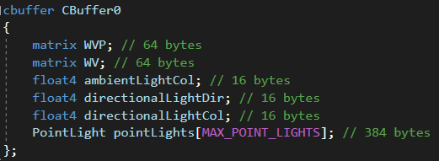
- Inside ReflectiveVShader.hlsl, add another matrix named WV to the constant buffer.
This is the same as the WVP but without the projection matrix concatenated into the matrix. This is because we need to have a world representative matrix that isn’t affected by the camera frustum for our reflection vector calculations.
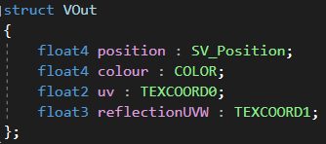
- The VOut struct will also need another texture coordinate, this time a 3-dimensional coordinate for sampling the skybox cubemap.
Because we now have multiple TEXCOORD semantics being used, we must enumerate them with 0 and 1 on the end.
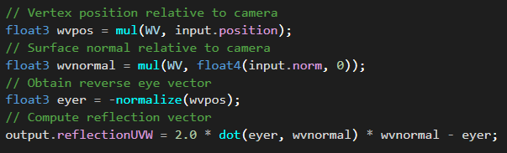
- Inside the vertex shader, we now need to calculate the reflection vector using the WV matrix.
The result is stored in the output variable. This will be interpolated between vertices when handed to the pixel shader.
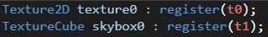
- Inside the reflective pixel shader, we now need to use two textures: standard texture for our object, and the skybox cubemap texture. To use multiple textures, we must assign them to different registers.
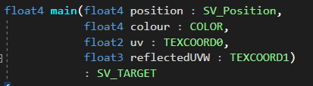
- In the vertex shader, we added another texture coordinate for the 3D reflected vector. We need to make the pixel shader know about this. If you are using a struct for PIn data, add the following to the struct. Otherwise, this needs to be added to the parameter list of your pixel shader.
Remember to enumerate the texture coordinate semantics, just like we did with the vertex shader VOut struct.
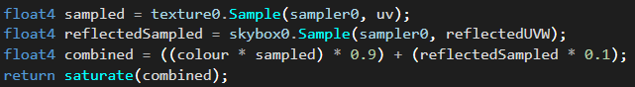
- The pixel shader code can now sample the cubemap using the reflected UVW coordinates, and mix it into the normal pixel shader output.
The above code is the entirety of the pixel shader.
The first line samples the texture just like before.
The second line samples the skybox cubemap with the reflected (and interpolated) vector.
The third line mixes both samples together, 90% being standard texture + lighting, 10% being skybox reflection. I have hard-coded this but you can use constant buffers to control the shininess of materials.
Finally, we use saturate to clamp the colour values between 0 and 1.
Later, experiment with different ratios to see how it affects the final render.

2. Using Reflection Shaders
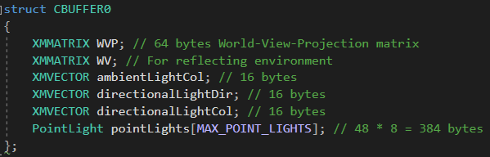
- Update the constant buffer to include the newly added WV matrix that we added to our vertex shader constant buffer.
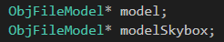
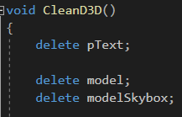
- Let’s now use a dedicated cube mesh for the skybox so that we can load whatever other models that we may need. This just means having another model specifically to store a cube for the skybox.
Make sure to load a cube obj file into it in InitGraphics and release it in the cleanup function.
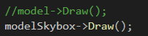
- Inside DrawSkybox, now use the skybox model.
- Inside InitPipeline, load the reflective shaders instead of the previous standard/lit shaders.
You can optionally create more COM objects to store both reflective and non-reflective shaders if you wish to use both for different objects.
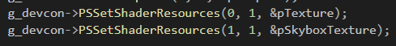
- Inside RenderFrame, we need to set two textures for our pixel shader: one for the object’s actual texture and one for the skybox cubemap that will be reflected.
We can specify which register each texture is going into by changing the start slot parameter. This will put the standard texture into register 0, and skybox texture into register 1, which matches our pixel shader.
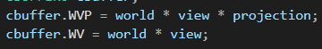
- Finally, we need to set the WV matrix in the constant buffer for our draw call. This is in RenderFrame.
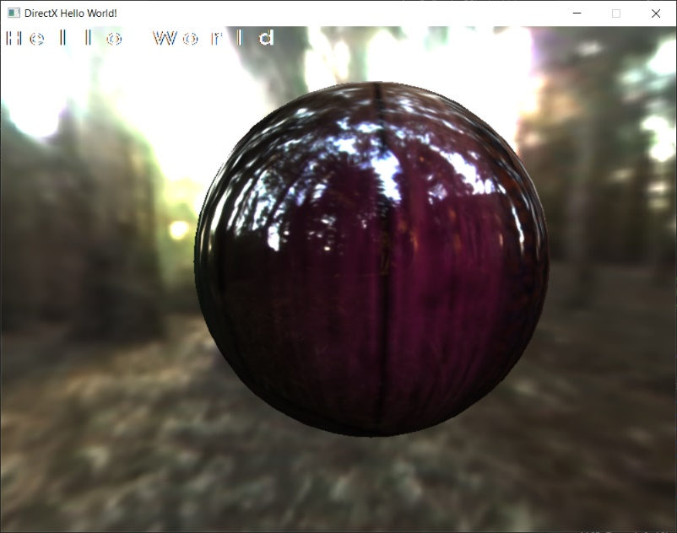
- Run the program. You should see your model being rendered with both the standard texture and the skybox reflected onto it.

